Getting started with Word 2016

Microsoft Word 2016 is a new, modern version of the classic desktop application, built for maximum productivity. Quickly produce professional documents using the rich authoring features. Share, present, and work together on projects with built-in team collaboration tools. Access your documents in the cloud whenever and wherever you need them. Word 2016 is now better than ever.

NOTE: This guide covers the desktop client version of Word 2016 for Windows. Some of the features below are not yet available in Word 2016 for Mac. To learn what’s new in Office 2016 for Mac, please visit [support.office.com](https://support.office.com/).

# What’s new

Word 2016 has new features, built so you can do great work with smart tools that help you stay on task. To learn more about new features that are offered across the suite of Office applications including Tell Me, Smart Lookup, Ink Equations, Save As improvements, new charts, simplified sharing and more, check out the *What’s new in Microsoft Office 2016* IT Showcase productivity guide at <https://aka.ms/WhatsNewOffice2016>.

# Getting started

If you are not familiar with Word, the information in this section will help you create beautiful and engaging documents.

## The ribbon

Find the commands to create your document in the ribbon at the top of the window.

Simplified sharing

Need help?

Ribbon tabs

Quick Access Toolbar

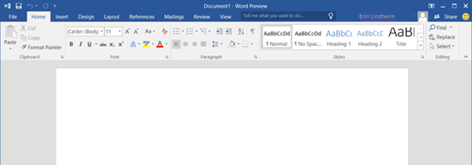

Minimize the ribbon

Smileys

Dialog box launchers

Backstage view

Figure 2. Elements of the ribbon

* **Quick Access Toolbar:** Commands located here are always visible. Right-click a command to add it to the Quick Access Toolbar.
* **Ribbon tabs:** Select any tab on the ribbon to display its buttons and commands. When you open a document, the ribbon’s **Home** tab is displayed. This tab contains many of the most frequently used commands in Microsoft Word.
* **Need help?** Use **Tell Me** or press F1 for help.
* **Simplified sharing:** Select **Share** to quickly invite others to review or edit your documents. See the “Simplified sharing” procedure in this document to learn more.
* **Microsoft Office Backstage view:** Select **File** to open, save, print, and manage your documents.
* **Dialog box launchers**: If you see the ribbon3 icon next to any group of ribbon commands, you can select it to open a dialog box with more options.
* **Minimize the ribbon:** Select the arrow to close the ribbon and show only the tab names.
* **Contextual ribbon tabs:** Some tabs appear on the ribbon only when you need them. For example, if you select a table, you will see the **Table Tools** contextual tab, which includes two extra tabs: **Design** and **Layout**.

ribbon2

## New documents

When creating a new document, you can start either from a blank document or a template, or you can create a new version from a previous document.

### Start from a blank document

1. Select the **File** tab, then select **New**. The **New** tab appears.

NOTE: When you first start Word, the **New** tab opens on the right by default.

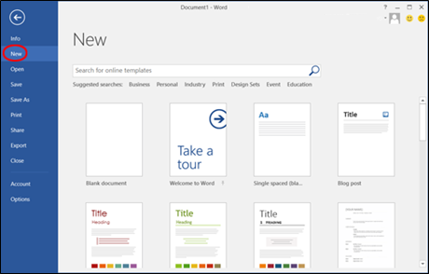

1. Select **Blank document**. A blank document opens.

### Start from a preset template

1. Select the **File** tab, then select **New**.
2. Select one of the preset document templates to open the template.

### Start from a custom template

1. Select the **File** tab, then select **Open**. The **Open** tab appears.

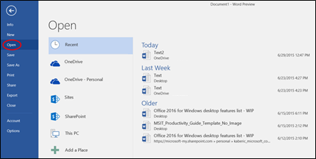

1. Navigate to the custom template and select the one you want to open.

### Start from a previous document

1. Select the **File** tab, then select **Open**. The **Open** tab appears.
2. Navigate to the previous document and select the document you want to open.

NOTE: If you are using the previous document as a starting point for a new document and do not want to write over the previous document, make sure you save by selecting **Save As**, not **Save**.

## Styles

Give your documents a professional look with Styles. You no longer have to remember how you formatted the last heading or previous paragraphs since Styles options will provide consistent formatting.

### Use styles

1. Select the text to which you want to apply a style.
2. On the **Home** tab, in the **Styles** section, select the style to apply to the text.

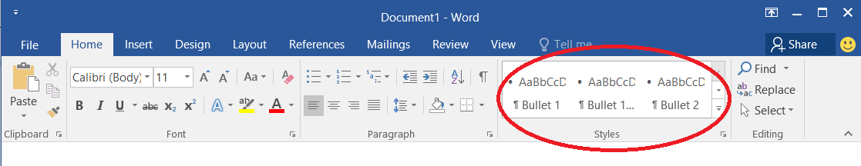

## Researcher

# Researcher allows you to search for any topic, insert images, and plug in content directly from the web without leaving your Word document. Researcher will even prepare the academic citations for the works cited.

# You can find Researcher on the **References** tab.

# 

1. Select **Researcher**. When the Researcher side pane appears, you can search for information on a topic by typing the relevant words or phrases into the search field.

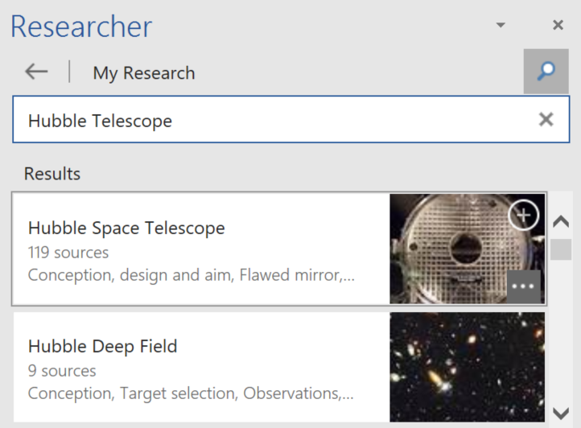

1. You can annotate your document with research information by selecting **Add Heading** ( **+** icon) on the upper right corner of the image, which will insert the search word into your document and a note in the margin that links to the source content for more information. This will also save information to the **My Research** section for future reference even if you decide to delete the research word or phrase from the body of the document.

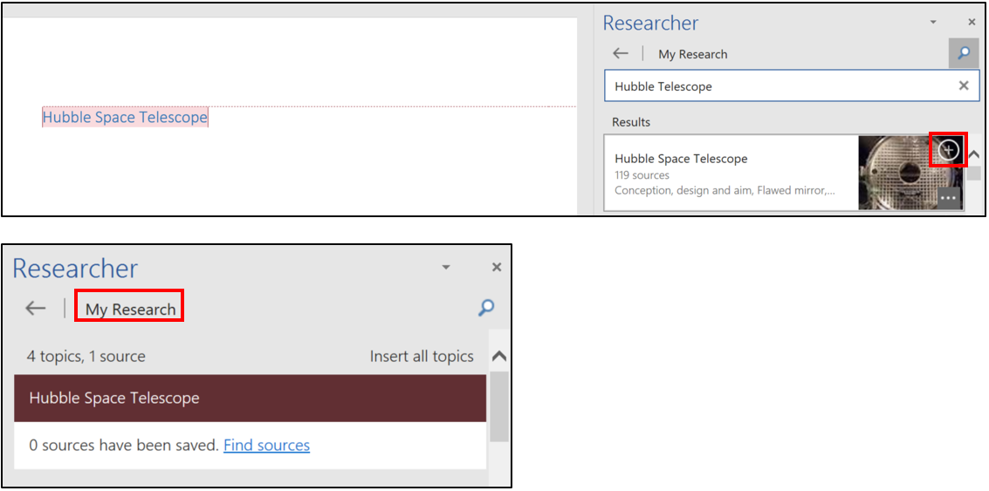

## Art and media

Make your document come alive by adding pictures and videos.

### Adding a picture or a video

1. Position your cursor where you want the picture or video added.
2. Select the **Insert** tab, and do one of the following:

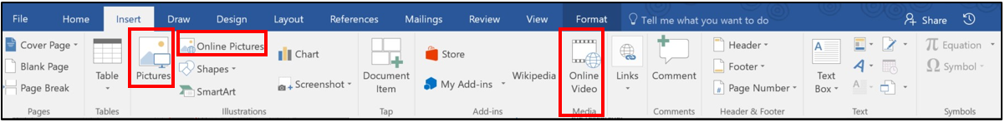

* In the **Illustrations** group, select **Pictures**.
* In the **Illustrations** group, select **Online Pictures**.
* In the **Media** group, select **Online Video**.

1. Navigate to the picture or video you want to add.

# Collaborating and sharing

Get your team on the same page by using built-in collaboration tools to share and co-author documents.

## Real-time co-authoring in Word

Work together on the same document by using real-time co-authoring in Word 2016. Everyone on your team can simultaneously edit the same document. Flags indicate where teammates are working in the document, and you can see their edits as they make them with real-time typing.

This capability is available when you are working in documents stored on Microsoft OneDrive for Business and Microsoft SharePoint Online. When another person opens the same document, you are both prompted to opt in if you have not previously done so.

NOTE: Opting in to real-time co-authoring is an application setting that applies as you work in different documents. Once you opt in, whenever you are in a collaborative space with others who have also opted in or who are co-authoring in Word 2016, they will see your changes as you make them. If you choose, you can toggle off the real-time co-authoring setting to opt out.

### Opting in to real-time co-authoring

1. Open a document stored on OneDrive for Business or on SharePoint Online.
2. When you are prompted to share changes, select **Yes**. Real-time co-authoring is active for any document you work on in a collaborative space.

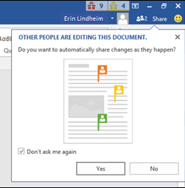

NOTE: You will only be prompted if someone else is working on the document or opens the document while you are working on it.

## Threaded comments

Threaded comments in Word 2016 allow people to have relevant conversations next to document text. Anyone reviewing the document can view comments that are added, including who added the comment and when it was made.

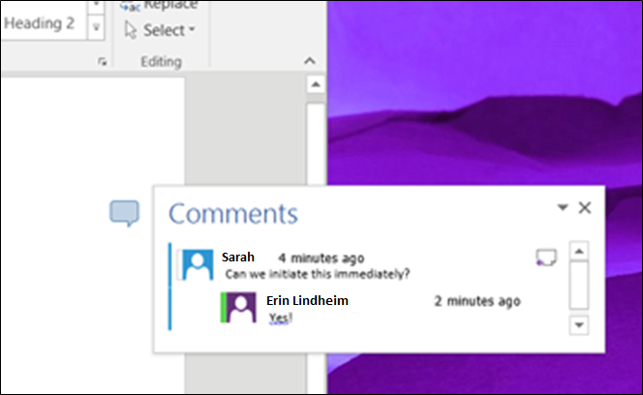

Figure 5. Threaded comments show comments and responses.

### Using threaded comments

* In a comment to which you want to reply, select the **Reply** button to add a response.

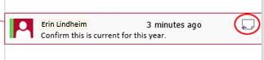

## Improved version history

You don’t need to be concerned as you and your team make edits and changes within the same document. Improved version history allows you to view or revert to earlier drafts, and it makes it easy for you to find previous versions of files stored on Microsoft SharePoint or OneDrive for Business.

### Opening a previous version

1. Select the **Activity** button in the upper right hand corner of Word 2016.
2. The Activity pane will open, allowing you to select previous versions of the document that you want to restore.

## Simplified sharing

Simplified sharinglets you quicklyinvite others to review or edit your documents. You can save your file to the cloud and make it available to others without having to navigate away from your work.

### Sharing a file

1. Select **Share**, above the ribbon on the right side.

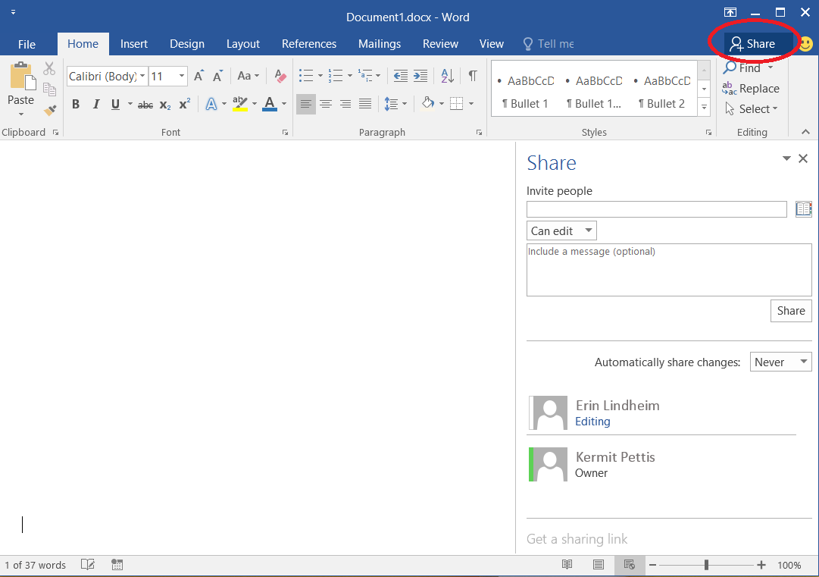

1. If the document is already saved to the cloud, skip directly to step 4. Otherwise, in the **Share** pane, select **Save to Cloud**.

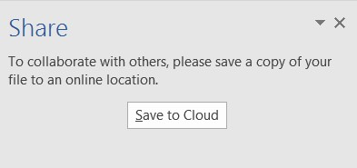

1. On the left, under **Save As**, choose the location where you want to save the document, then select the target folder on the right.
2. Select **Save**.
3. In the **Share** pane, invite people, and choose whether they will have permission to edit or just view the file.

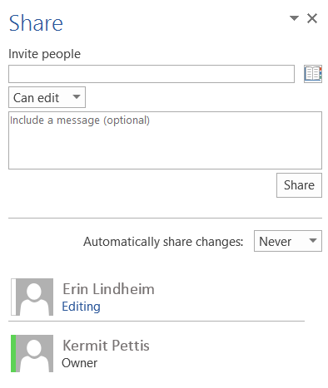

## More intuitive navigation of cloud storage

More intuitive navigation of cloud storage locations makes it even easier to access, edit, and share your Word 2016 documents, no matter where you are. Working in the cloud not only means you can share and work with your colleagues, but also means your documents are protected from loss. In addition to the redundancy in cloud storage, Word 2016 also maintains a version history when documents are stored and edited on either OneDrive for Business or SharePoint Online.

# Using Word 2016 on a phone or tablet

In addition to working with Word on a computer, you can use Word (part of Microsoft Office Mobile) on a Windows Mobile device, an iOS device, or an Android device. To get started with installing and setting up Word on a mobile device, visit <https://support.office.com/en-us/word>.

# For more information

## Microsoft IT

[microsoft.com/itshowcase](http://www.Microsoft.com/ITShowcase)

## Microsoft Office Support

[support.office.com](http://support.office.com)

© 2016 Microsoft Corporation. All rights reserved. Microsoft and Windows are either registered trademarks or trademarks of Microsoft Corporation in the United States and/or other countries. The names of actual companies and products mentioned herein may be the trademarks of their respective owners. This document is for informational purposes only. MICROSOFT MAKES NO WARRANTIES, EXPRESS OR IMPLIED, IN THIS SUMMARY.